Microcomputer Design

Chandler Griscom

15Jan2016

Design Report #5

- Time – 32.25 Hours total
  - Week 4 (Wed-Sun) – 13.5 Hours
  - Week 5 (Mon-Wed) – 18.75 Hours

- Accomplishments
  - Soldered Board
  - Finished VHDL
  - Tested ROM and RAM, ran simple programs (after lots of debugging)
  - Established DUART communication (after lots of debugging)
  - Implemented DUART and periodic (1ms) interrupts

- Planned Work
  - Begin writing monitor program
  - Start thinking about the flash-writing process

- Project Completion
  - Hardware: 100%
  - Software: 30%

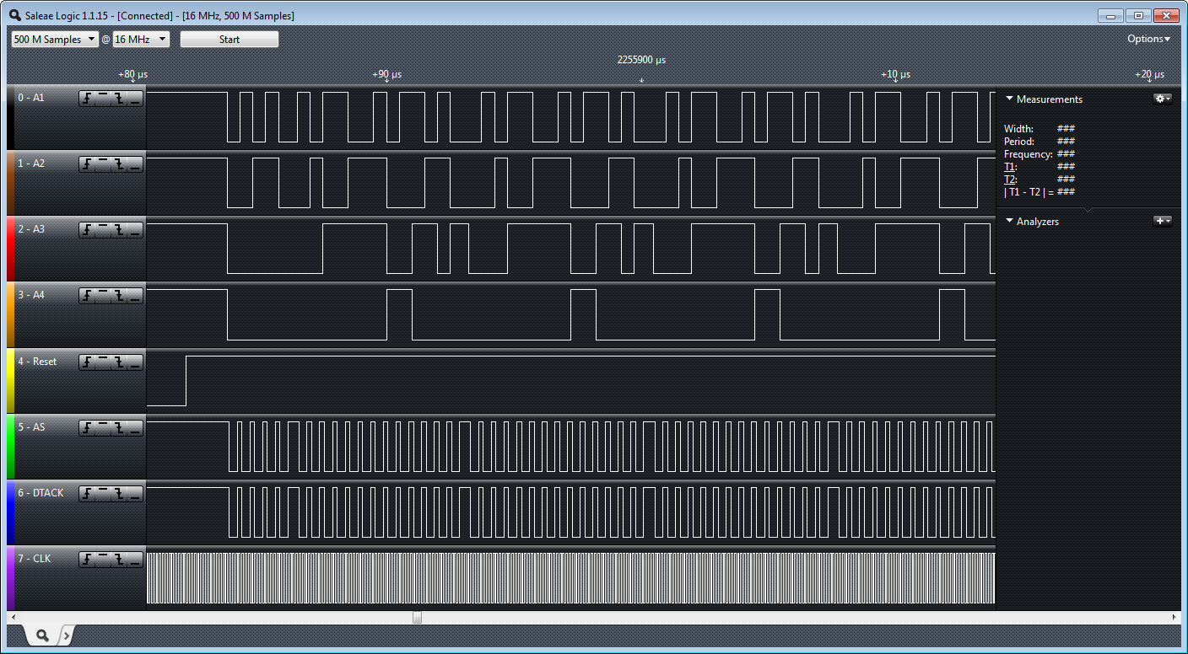
RAM-testing loop waveforms

